**CS624 Full-Stack Development Mobile App**

**PE05 – Cities with Countries and Currency**

Developed by Sam Chung on February 25, 2022

School of Technology & Computing (STC)

City University of Seattle (CityU)

**Before You Start**

* You already created a private GitHub repository for all your programming exercises, “cs624-pe-your_first_name.”
* You allowed your instructor and the Teaching Assistant to access your GitHub repository for programming assignments.
* The GitHub Codespaces may bill your account according to your usage. Check the price at <https://docs.github.com/en/billing/managing-billing-for-github-codespaces/about-billing-for-github-codespaces>.
* Some steps are not explained in the assignment**.**If you are not sure what to do:
  + Consult the resources listed in your course.
  + If you need help solving the problem after a few tries (~15 minutes), ask a TA for help.

**Learning Outcomes**

Students will be able to:

* Implement additional screens by adding more tabs to the bottom tab navigator.

**Problem**

In this week’s HOS, you have learned how to create Bottom Tab Navigator and add Screens to the Cities App.

For this programming Exercise, you are expected to enhance the Cities App by adding additional Screens.

1. You will create two more tabs AddCountry and Countries.
2. You will take Country Name and Currency as input to add a country to the list.
3. In the Countries tab you will show the Countries list and their currency.

Save your changes to a different directory in this week’s HOS repository.

|  |  |  |
| --- | --- | --- |
| Figure 1.  Initial Screen with four tabs | Figure 2.  The AddCountry Tab | Figure 3.  The Countries Tab |
|  |  |  |
| Figure 4.  The AddCountry Tab | Figure 5.  The Countries Tab |  |
|  |  |  |

**Submission**

1. If you already created a GitHub repository for your programming exercises, “cs624-pe-your_first_name,” create a directory for programming exercise 5, “PE05-CitiesWithCountriesCurrency.” For example, the screen below shows that the following seven directories were created for all programming exercises.

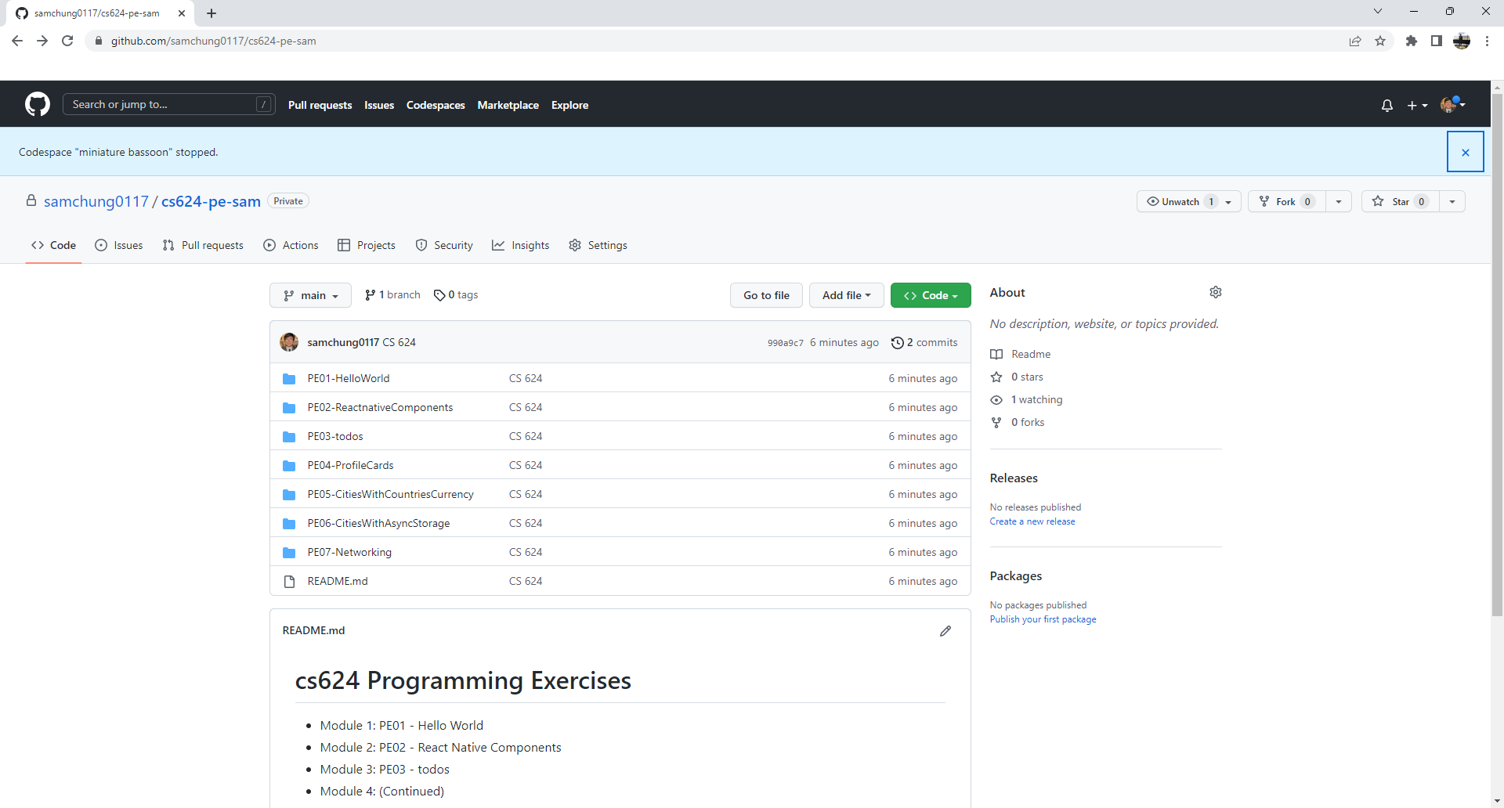

1. Finish your programming exercise under the PE05 directory.
2. Write a 150-word analysis report to explain how the program works in [README.md](https://www.markdownguide.org/basic-syntax/) regarding the [input-process-output model](https://press.rebus.community/programmingfundamentals/chapter/input-process-output-model/). The README.md has three level-1 headings – Input, Process, and Output.
3. Submit the link of your GitHub repository to your course shell through your assignment submission.